TRUMPERY IN SCOTLAND
A web post comment by Jeremy Pern
July 2013

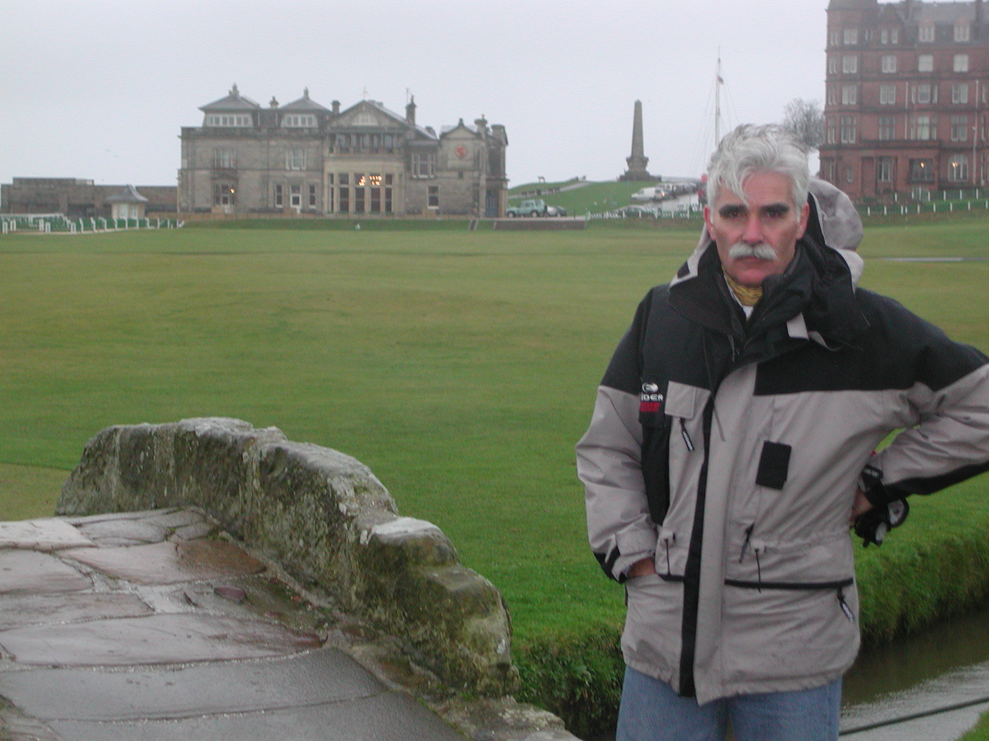

To expect the EIGCA to "issue a statement" about the Trumpery up north is like asking the members of the Nation Rifle Association to become Vegans. The European Institute of Golf Course Architect's only living "Fellow" is Trump's designer, Dr Martin Hawtree, who as a person and as a golf course architect I have great respect. I believe that Dr Hawtree was naive and disgracefully ill-used, or is not the honourable man I believe him to be. Some people in the Golf Industry did in fact publicly oppose this project in the golf press at planning stage, notably Jonathan Smith and his all singing and all dancing GEO outfit, Mike Wood and myself included. All to no avail of course- Scots politicians being what they are.

Many of us believed at the time that the only architect capable of giving Trump the street cred he required to get the permits through was Dr Hawtree, and we were proved right. I believe that had anyone other than Dr Hawtree done the job the result would have been somewhat less impressive. It is always difficult to say no to a project on moral grounds, especially when it has such a high media profile and on such a spectacular site.

Ones own moral compass is a private thing and to judge other architects choices is a risky business. However I do regret that the UK golf establishment's stunning silence has effectively condoned the appalling behavior of Golf's very own school yard bully.

Check out “Golf Industry Professionals” - Linked In Group – David Jenkins started a chat called “You’ve been Trumped “ about 4 months ago –some good comments worth looking at if the subject interests anyone out there. My own comments made then were as follows

"If Trump's course is not a truly remarkable and excellent golf course something must have gone very wrong indeed. With such a stunning site, unlimited budget and an old school golf course architect, Dr Hawtree, doing his traditional Golden Age stuff, how can it be otherwise. However the quality of the golf course is totally irrelevant. Jeremy Slessor has accurately and succinctly detailed the ecological and environmental issues of the project which many of us raised during the early development phase.

The appalling behaviour of some leading Scottish politicians should come as no real surprise to those who followed the Libyan (Slight Return) debacle a couple of years ago. However, for those of us in the golf industry, the issues are rather more serious as they affect our professional reputation as viewed from the outside. The crass vulgarity, cupidity, self-interest and lack of reasonable standards that has crept remorselessly into many aspects of golf over recent years is neatly represented in my own mind at least by two events- Tiger Woods' reported design fee of $27,000,000 US for his as yet to be finished "track" in the desert sands of Dubai, and Mr Trump's sandy waste in Aberdeen.

Bashing our American cousins for their cultural differences is not a productive exercise. Trump is no more representative of America than Jack the Ripper is of England The tragi-comedy of Trump's Sandy Waste goes far beyond politics and the environment.

It is perhaps worth recalling the old fairy tale of the Emperors New Clothes. The role of Emperor has been played by Scotland, flattered by a scheming wheeler dealer tailor, played of course by Trump. The sycophantic courtiers who have shamelessly flattered the Scottish Emperor for their own profit all come from the ranks of our own Golf Industry- the journalists, architects, builders, managers, green keepers and pro's. And Golfers. The child who cries out "Mother! Look! The Emperor is naked" is perhaps the director of "You've been Trumped"

The tragedy that is still to be played out will, I'm convinced, include a financial loss on the part of investors, a ruined dune scape on a never to be completed golf resort development, the humiliation and trashing of a proud nations remarkable golfing heritage and the wilful battering of our own industry's already dismal reputation.

All that remains will be a remarkable golf course doubtlessly giving great pleasure to the lucky mindless few that can afford to play there. But the cost of this tawdry bauble is simply too high. And I'm not talking about the dollar price tag.

Mr Trump, just because you can do something doesn't mean you should."

